Circuit Analysis (Lab # 2)
Experiment 2: Measurements of Waveforms and Fundamental Quantities, Basic resistive circuits.

Name: Ailia Zain Registration No: 2025-CE-46

Date: 15th March, 2026 Grade and Signature:

CLO3 | Make measurements in their own constructed electric circuits.
Psychomotor/Affective | Level1  (1) | Level2 (2-3) | Level3 (4-5) | Level4 (6-7)
Report Marks (3) |  |  | Total marks  (10)
_______________________________________________________________________________
_
Objectives:
This experiment will provide exposure to measurements of waveforms and Fundamental Quantities, Basic resistive circuits. A primary purpose of this lab course is for you to master the use of electronic test equipment and measurement of fundamental quantities.
Equipment required:
Power Supply, Breadboard, Oscilloscope, Signal Generator Connecting wires, Resistances, Multimeter.

Experiment # 1
SIGNAL GENERATOR AND OSCILLOSCOPE
Procedure:
- Use the signal generator and the oscilloscope to perform the following tasks.
- Build circuit ‘A’ shown below in Figure 1.
- Set the signal generator to generate a sinusoidal signal with a frequency of 100 Hz and peak-to peak voltage of 5V.
- Set up one probe across input signal, and another across R1 and R2 alternatively.
- Measure and draw all the voltages and time related parameters on the graphs below.
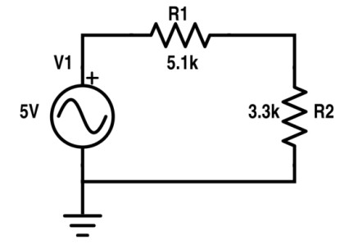
Figure 1 Circuit ‘A’

Resistor | Input voltage | RMS Voltage | P-P Voltage
R1 | 5V | 1.07V | 3.04V
R2 | 5V | 0.69V | 1.96V

0 t/4 t/2 3t/4 T 0 t/4 t/2 3t/4 T

1.52
0.5
0
-0.5
-1.52
2.5
1.5
0
-1.5
-2.5


V
V

Figure 2 Input Voltage Signal Figure 3 Voltage Signal across R1


V
V
3.5
1.5
0
-1.5
-3.5
0.98
0.45
0
-0.45
-0.98
0 t/4 t/2 3t/4 T 0 t/4 t/2 3t/4 T
Figure 5 Voltage Signal across R2 | Figure 6 Draw 7V Sinusoidal

Experiment # 2

SIGNAL GENERATOR AND OSCILLOSCOPE
- Use the signal generator and the oscilloscope to perform the following tasks.
- Build circuit ‘B’ shown below in Figure 7.
- Set the signal generator to generate a sinusoidal signal with a frequency of 200 Hz and peak-to peak voltage of 7V.
- Set up one probe across input signal, and another across R1, R2 and R3 alternatively. 5.
- Measure and draw all the voltages and time related parameters on the graphs below.
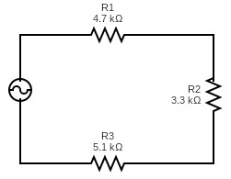
 |  | Figure 7 Circuit ‘B’
Resistor | Input voltage |  | RMS Voltage |  | P-P Voltage
R1 | 7V |  | 0.89V |  | 2.51V
R2 | 7V |  | 0.62V |  | 1.76V
R3 | 7V |  | 0.96V |  | 2.73V
R1 and R2 | 7V |  | 1.51V |  | 4.27V
R2 and R3 | 7V |  | 1.58V |  | 4.49V



Figure 8 Input Voltage Signal Figure 9 Voltage Signal across R1

Figure 10 Voltage Signal across R2 Figure 11 Voltage Signal across R3

Figure 12 Voltage Signal across R1 and R2 Figure 13 Voltage Signal across R2 and R3

Post Lab Questions
- Define Ohm’s law.
Ohm’s Law states that the current (I) flowing through a conductor between two points is directly proportional to the voltage (V) across the two points, provided physical conditions (like temperature) remain constant. The formula is V = IR.
- What is resistor?
A resistor is a passive electrical component that creates resistance in the flow of electric current. It is used to limit current, divide voltages, and protect sensitive components. It can be expressed as R=V/I
- How resistor works?
A resistor works by converting electrical energy into heat energy through the collision of electrons with the atomic structure of the resistive material. This "friction" restricts the number of electrons that can pass through per second (current).
- What is your inference from the input and output waveforms on oscilloscope?

In a purely resistive AC circuit, the input and output waveforms are in phase (they reach peaks and zeros at the same time). The output waveform has the same frequency but a smaller amplitude than the input, depending on the resistance values (Voltage Divider Rule).

- Show calculations of 7V input signal (Figure 10) from signal generator.
  - Voltage calculations (Following volt/dev and number of boxes of oscilloscope)
  - Frequency/Period calculations (Following Steps in frequency measurements section)
  - Current calculation (Ohm Law)
- Vp-p = 7V
Vrms = 7/2 sq.2
Vrms= 2.47V
- F = 200Hz
- I = Vrms/RT
I = 0.189mA

